SAT Prep: Close reading (gift-giving) NAME:_______________________________________

DIRECTIONS: Read the “gift-giving” piece and graph. Fill in the annotation boxes and complete any other necessary tasks as per instructions.
Note the context, which lets you see whether you are reading fiction or nonfiction. The title may hint at the content of the passage or the author’s tone. Also, the date may prove useful. Consider that context to help you preview/understand the reading.

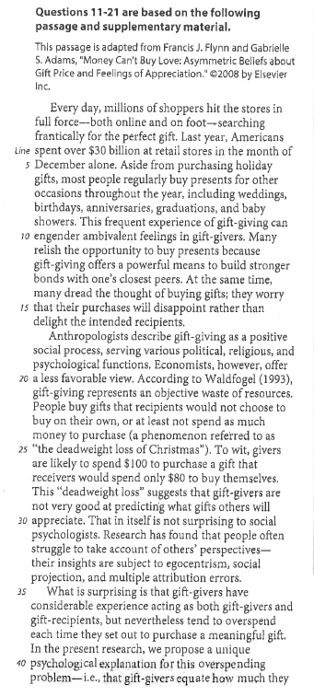
2. Lines 19-34: Summarize: what’s a key ECONOMIC issue associated with gift-giving?
1. Lines 9-16: What is the author comparing/contrasting? Explain.

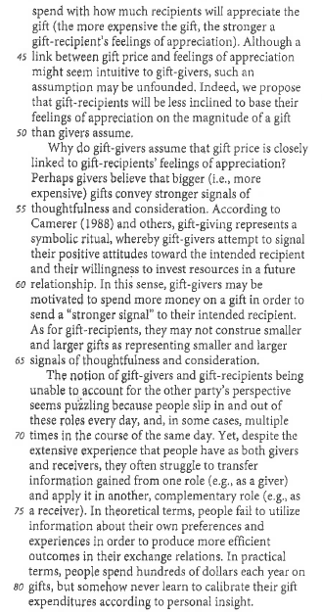
5. Lines 75-78: The passage provides information about people in general. Rewrite that sentence to explain how that general information applies to the subject (gift-giving) of this passage.
4. Lines 51-63: Explain why, according to researchers, some people overspend on gifts.
3. Lines 35-50: Paraphrase (put in your own words) the theory about gift-giving.

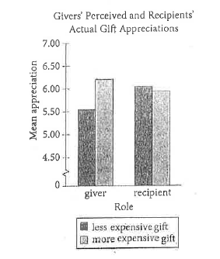
6. “Read” the chart that accompanies the article. Choose the answer to fill in the blank based on your understanding:
- The chart reveals that a giver assumes that a MORE / LESS expensive gift will be valued more.

7. Select the correct answer: The chart notes that a recipient thinks:
- A more expensive gift has a higher value
- A less expensive gift has a much higher value
- A gift’s price has little impact on its value

8. Highlight a piece of evidence in the passage (the article) to support what the graph reveals.

